**ReadMe**

**Programming Language Used:** C++  
**Library Used:** Bits/stdc++.h  
**Logic Used:** 1. Standard input is taken in the form of ordered pairs like (1,1), (2,2) etc.  
2. Relation is represented in the form of the matrix and a[i][j]=1 if (i,j) belongs to the relation R, else a[i][j]=0.  
3. If relation is reflexive (all diagonal elements are 1), antisymmetric (if a[i][j]=1 then a[j][i]=0), and transitive (a[i][j]=1 and a[j][k]=1 then a[i][k] is also 1) then it is a poset.  
4. If every 2 elements of poset have LUB and GLB then it is a lattice.  
5. For every 2 elements of a poset to have LUB and GLB they must be comparable. If they are incomparable, they can’t have LUB and GLB.  
**How to compile**- Copy the given code as it is on any online C++ compiler and run the program and   
give the inputs. Link for one online compiler is- <https://www.onlinegdb.com/online_c++_compiler>

OR

Copy the code on any IDE with C++ compiler installed on your computer. Build the program and run.

**Code Screen Shot-**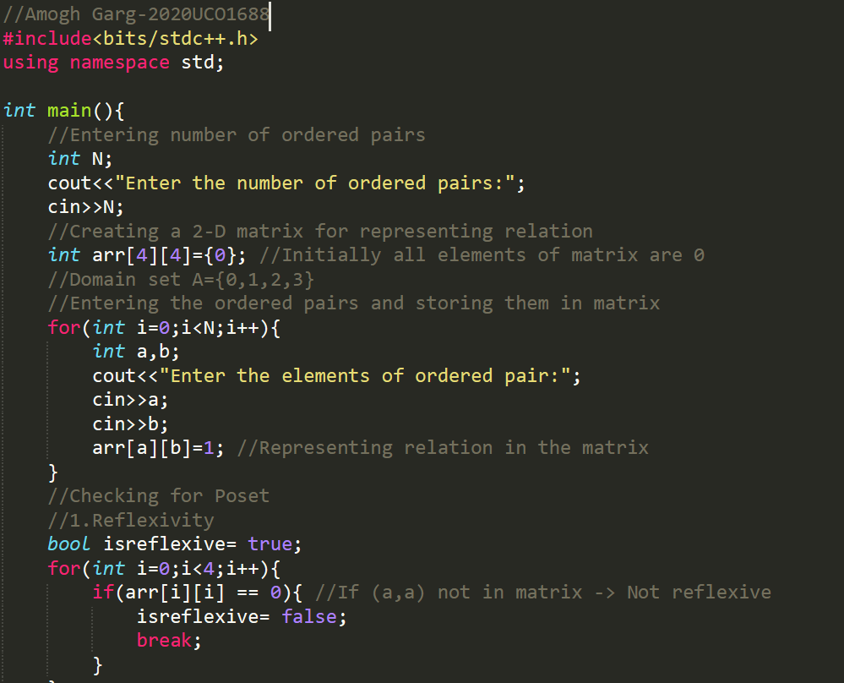

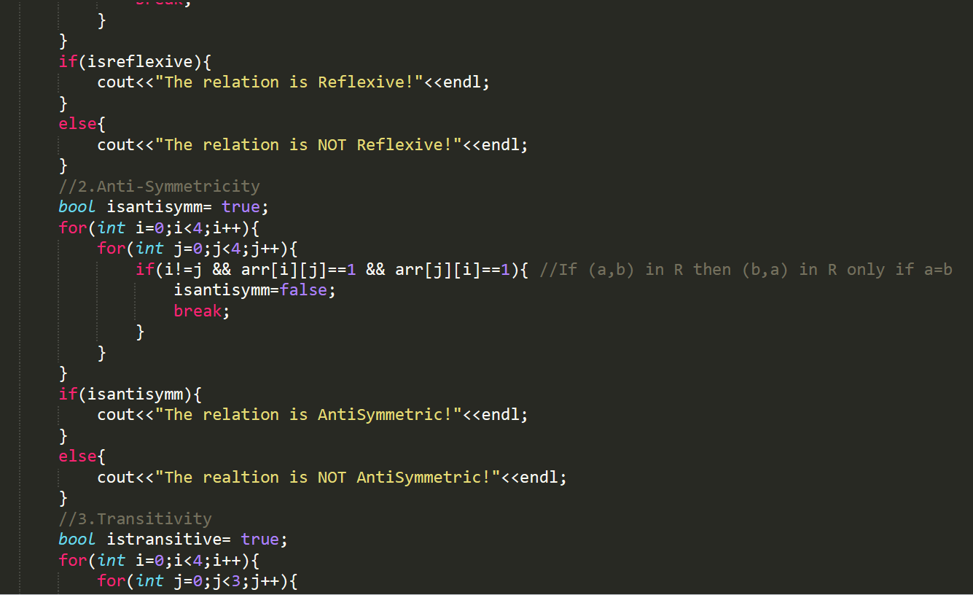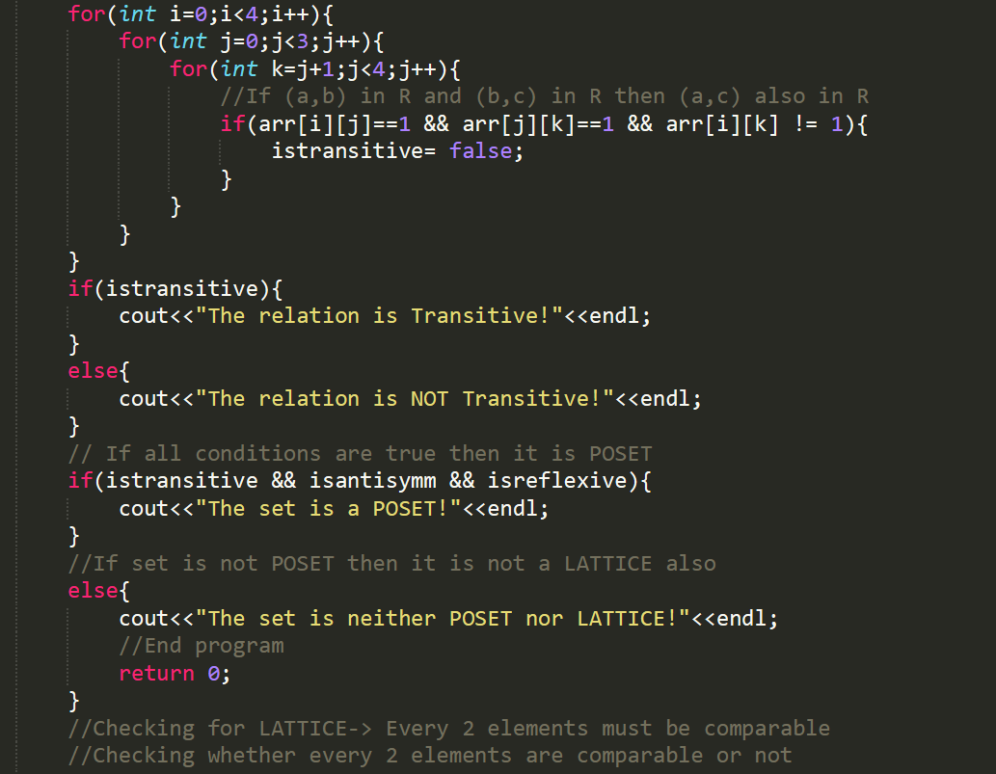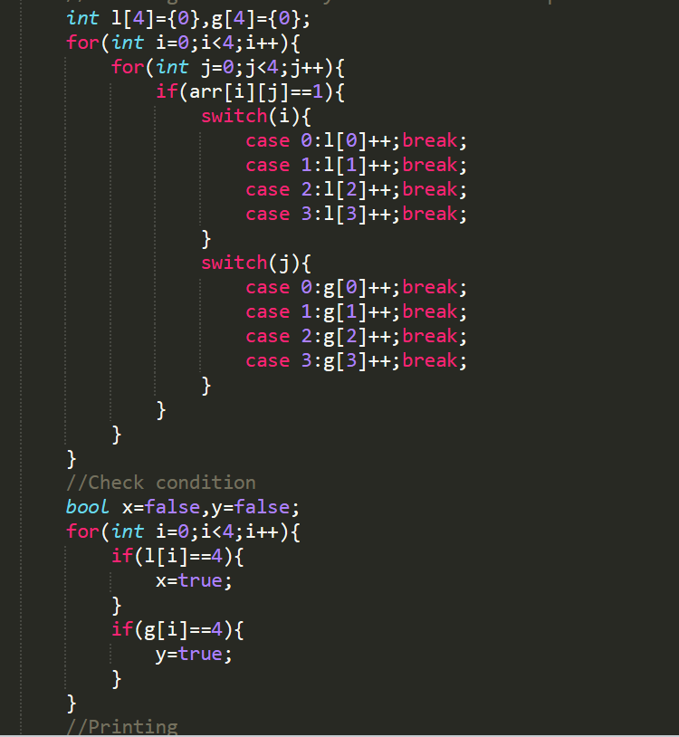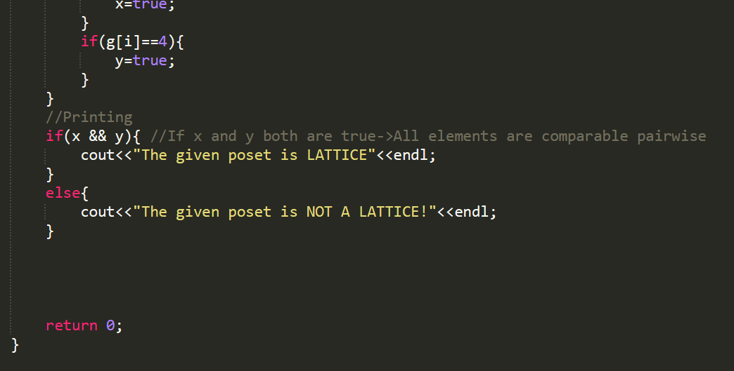

**By: Amogh Garg  
2020UCO1688**